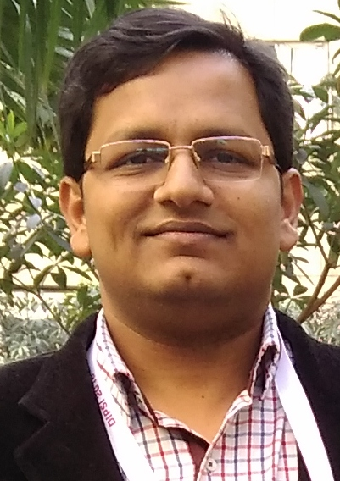 **Dr. VishwasTripathi**

**Assistant Professor**

School of Biotechnology

Gautam Buddha University, Greater Noida

**Email**: vishwas@gbu.ac.in

drvishwastripathi@gmail.com

**Eligible to supervise** Masters and PhD students– email on vishwas@gbu.ac.in to discuss the availability

**Research Area**: Cancer Biology

My research area includes identification & elucidation of Molecular mechanisms of **novel anti-cancer drugs.**The developing knowledge of cancer biology suggests that the tumor mass is heterogeneous and the root cause of cancer origin, drug resistance, and metastasis is **Cancer stem cells (CSCs)**. The conventional drugs work at the fast-dividing cancer cells but they hardly target the slow-dividing cancer stem cells which are the real culprit for the cancer rejuvenation. Therefore, the need of the hour is to identify novel drugs which can target these slow-dividing cancer stem cells so that the cancer recurrence and metastasis can be checked. We have identified the molecular mechanism of action of several anticancer natural compounds (Crocetin, Piperine, Papain, Transferullic acid, P-coumaric acid, Quercetin, Quinic acid, Vitamin D, etc) in smokeless tobacco and nicotine-induced human head and neck cancer cells. Moreover, we have investigated the synergistic interaction of some of these compounds with the Cisplatin, a well known anti-cancer drug.

**My current research work includes:**

* **Screening and identification of novel anticancer natural compounds from various sources (Dietary compounds present in fruits, vegetables, spices, cereals, herbs compounds of microbial origin, marine algae, etc.)**
* **Investigation of the pharmacokinetic parameters of the lead compounds and their effect on markers genes of pro and anti-apoptotic pathways by *in silico* prediction and wet lab validation**
* **Understanding the regulation of the key cell survival pathways of cancer stem cells and their microenvironment.**
* **Identification of novel biomarkers in head and neck cancer.**
* **Synergistic interactions between the lead compounds and available chemotherapeutic agents.**

**The masters and Ph.D. students who are interested to work on thrust areas of cancer biology are most welcome to inquire at my e-mail Id.**